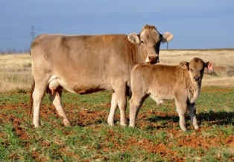 LSU AgCenter Beef Cattle Fact Sheet 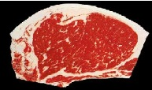
“Is Beef Cattle Temperament Important in Your Operation?”
Dr. Tim Page, LSU School of Animal Sciences

Is beef cattle disposition and temperament important to a successful operation? Research and my lifetime of cattle experiences have proven to me that docile cattle are more fertile, have higher average daily gains, are more feed efficient, healthier, and will produce carcasses with higher quality and yield grades.

How many of you have experienced cattle that are flighty, high headed, hard to pen, and just downright mean and dangerous to other cattle and people? Most of us have at some time or another. In today’s industry there are several tools that we can use to determine which cattle possess good temperament versus cattle with bad temperament. Research and producers have long used chute exit velocity, chute temperament, and visual observance when determining cattle disposition. Newer research is using EPD disposition and even location of whorls (cowlicks) to help determine cattle temperament. The higher the EPD disposition number the better. Higher cortisol levels also indicate poor disposition. Believe it or not, research is now showing that cattle with whorls lower on the face will have calmer dispositions. Cattle with whorls above the eyes will usually have worse dispositions than cattle that have whorls between the eyes or below the eyes.

That is probably enough about whorls, cowlicks and such. I help many producers select replacement heifers. I don’t care how good a heifer is (ultrasound scan data, visual score, soundness, femininity, balance, broodiness, boldness), if they act up in the chute, she is gone and she can be someone else’s problem. If a cow is ill tempered, her calf will be too and she needs to be culled. Temperament is fairly high in terms of heritability (40%). I do not want heifers/cows to be perpetuating bad disposition in my herd.

One recent study over 47,000 feedlot cattle were evaluated for average daily gain, feed conversion, morbidity, mortality, quality grade and tenderness. This study showed that docility is worth over $70 per head. That is a lot of money per head. That would mean that 75 head of calves in one pen in the feedlot might be worth $6,000 more just because of being docile. Because of increased profits, cattle safety, and worker safety, we should be advising beef cattle producers that selection for disposition and temperament should be high on their list of keeping and culling replacement heifers and cows.

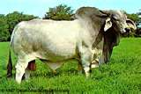

The LSU Agricultural Center is a statewide campus of the LSU System and provides equal opportunities in programs and employment.

